BUSINESS CASE VERSION 1.1

Project Name: | Sigrid
Date: | 06-11-2021 | Release: | TBC
Author: | Project – 5 [Tenzin, Faiz, Asiri, Divya, Ravali, Balagopal]
Owner: | Project manager
Client: | Challenge UK
Document Number:

Note: This document is only valid on the day it was printed

Revision History
Date of next revision:
Revision Date | Previous Revision Date | Summary of Changes | Changes Marked

Approvals

This document requires the following approvals. A signed copy should be placed in the project files.
Name | Signature | Title | Date of Issue | Version
 |  | The IT head |  | Final
 |  | The delivery manager |  | Final
 |  | The project champion |  | Final

Distribution

This document has been distributed to:
Name | Title | Date of Issue | Version
 | The IT head
 | The delivery manager
 | The project champions
 | Business analyst
 | Development lead
 | Test lead

Summary

Project Sigrid will implement a fully automated booking system across all the challenge UK offices. It will simplify the process of course/accommodation booking, voucher generation and also provide an online campaigning system that will advertise the less booked courses to the account customers.
As of now the company runs a primitive system to handle customer bookings and accounts. The company is in a growing stage with significant increase in bookings and the existing system is volatile and can break. This can downhill the business process. By implementing a not so complex and budget friendly enhancement in the IT system, the company will gain good amount of goodwill and profit.
The system would be developed in such a way that it is easily scalable and can be enhanced in future. Necessary artifacts are made based on calculations so tha t all aspects including cost and timelines are estimated beforehand. The architecture, design and implementation will follow accepted development methodologies.
The process started by suggesting the company to use a standard sale ledger package which can be later be connected to central DB to seed all data required to handle and process the accounts information of all the bookings.
Interviews with various department heads and staffs to understand problems and requirements to provide a feasible solution. Based on that a list of artifacts has been prepared to calculate the risk, cost estimation, timeline for execution, impact on the existing system and various communication points.

BENEFITS

- The managing director, activities director and the bookings manager can easily manage things as all the updates regarding bookings and accounts from all the offices are reflected instantly and can be view that status sitting in their own office.
- The booking clerks and hostel staffs can easily access the booking details of courses and accommodation both separately and individually so that there is no confusion as to which course/accommodation is booked and not booked.
- The reports introduced will give an overview to the bookings manager on the less booked courses and work on advertisement options.
- The quarterly sales report will give an overall status of the profitability of the company.
- A digital payment only system will help keeping track of the paid and unpaid vouchers.
- The chance of missing customer/booking details will be eliminated.

Outline of the proposed business system

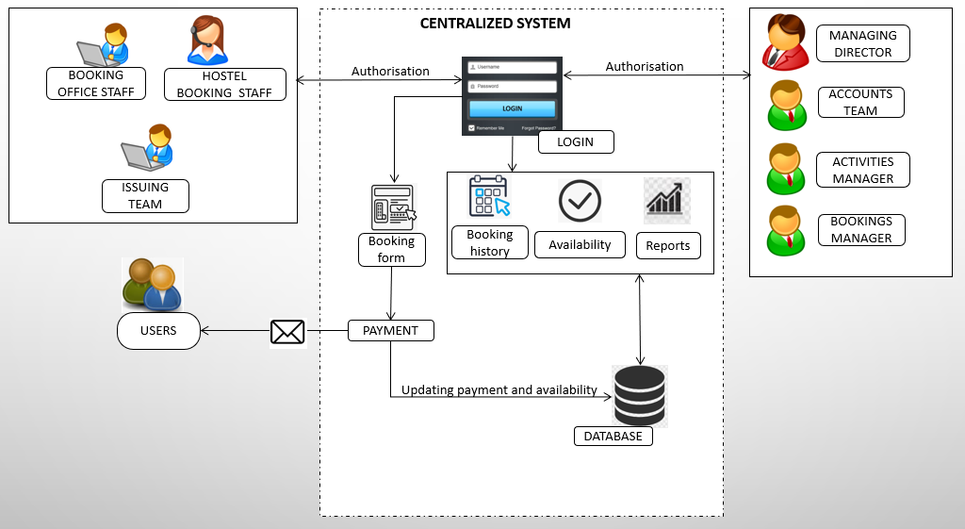

Project management structure

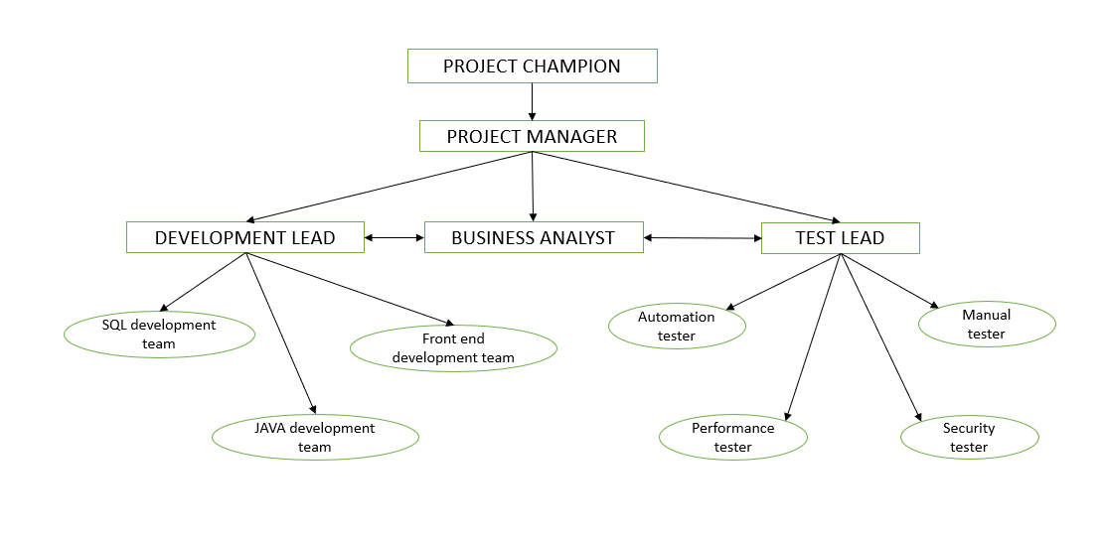

The following are the foundation for this business report

- Transcripts of interviews conducted with the stake holders of Challenge UK
- Risk Register table
- Power interest grid
- Cost and resource analysis
- Communication strategy table
- Gantt chart showing the time scale
- Functional& non-functional requirements.

RISK ANALYSIS AND DISBENEFITS

- Some of the staffs currently working might not be comfortable to shift to a new system as they are used to it.
- Staffs who will have less computer background needs to be trained well before that can make use of the system effectively.
- Removing all paper-based record keeping can be a risk as there is no secondary source of information.
- Imposing a digital payment only method can bring negative feedback among customers.
- Since it is an old and well know company with so many well-wishers who are used to the existing system may find it difficult when newer technologies are involved.

Risk Log

ID | Description | Probability | Impact | Risk Category | Response
1 | Introduce a shared IT system between all the offices and hostels | Medium | High | IT | Make a portal that has a user-friendly UI which can be used by all the staffs.
2 | IT scope not well defined | High | High | IT | The strategy docs and BRDs should be written in a clear and concise manner. Discussions should be done before the signoff and meetings should be scheduled whenever there is need for clarification
3 | Delay in obtaining the required hardware | High | High | Procurement | All orders should be made in advance. All approvals from management should be made promptly.
4 | Inadequate training for the staff about the new system | Low | High | L&D | Effective training should be provided for all the staffs so that they can migrate to the new system with ease. All training to be scheduled along with each module implementation.
5 | Transfer of existing data from paper files to digital files can involve chances of data loss if not done properly | Medium | High | Data team | Transfer standards to be maintained? If at all there is a chance of missing data, it can be cross referenced from the old paper documents.
6 | Introducing an all-digital /card only payment system can involve business loss. | Low | Medium | BA | Should not impose a digital only system.
7 | Delay from IT staff working from home | Low | Medium | Management, IT and procurement | Considering the current situation delay due to connectivity issues or hardware is possible and hence there should always be a backup plan and all the resources should be aware of this
8 | Discrepancy in cost estimation | High | High | PM | A well-defined cost estimation to be done to avoid future flaws
9 | Unavailability of adequate staff to handle the new system | Medium | High | PM | A skill-set matrix should be maintained and adequate training to be provided to all staffs lacking the necessary skills.
10 | Sudden change in business requirements | Medium | Medium | BA | All requirements should be finalized and signed off beforehand
11 | Emergency leaves from project members. | High | Medium | PM
12 | Sudden network outage in the office environment. | High | Low | PM | Issue laptops and dongle to each employee so that the project members can work from remote locations and not only from office. The broadband connection at home should also be reimbursable so that the members feel encouraged to perform and mitigate unexpected circumstances.
13 | Unexpected hardware issues. | Low | Low | PM/Procurement | PM should be in good contact with the procurement team and should liaise with the team to clear the gap as soon as possible.

Risk Map

IMPACT | high | - Unavailability of adequate staff to handle the new system. | - Introduce a shared IT system between all the offices and hostels.  - Inadequate training for the staff about the new system.  - Transfer of existing data from paper files to digital files can involve chances of data loss if not done properly. | - IT scope not well defined.  - Delay in obtaining the required hardware.  - Discrepancy in cost estimation
IMPACT | medium | - Introducing an all-digital /card only payment system can involve business loss.  - Delay from IT staff working from home. | - Sudden change in business requirements. | - Emergency leaves from project members.
IMPACT | low | - Unexpected hardware issues. |  | - Sudden network outage in the office environment.
 |  | low | medium | high
 |  | PROBABILITY OF OCCURRENCE

Power interest grid

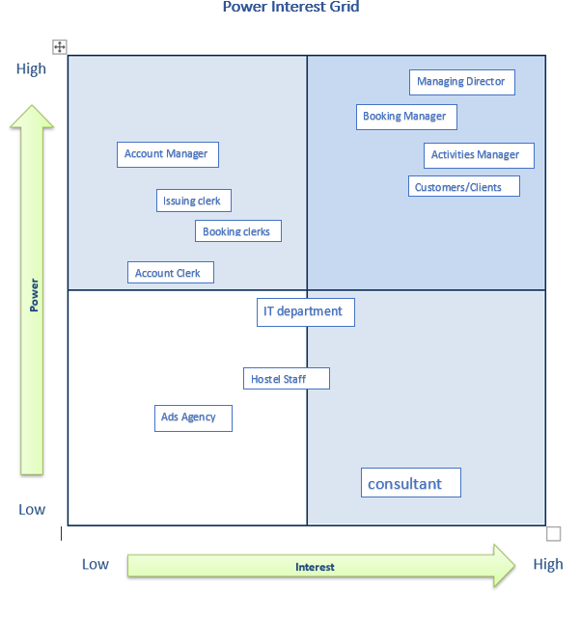



Cost and resource analysis

Reference: http://softwarecost.org/tools/COCOMO/

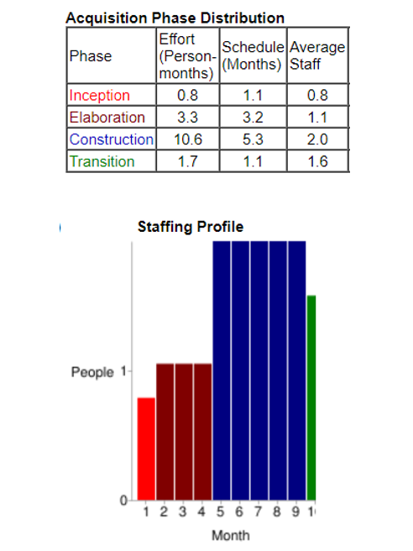

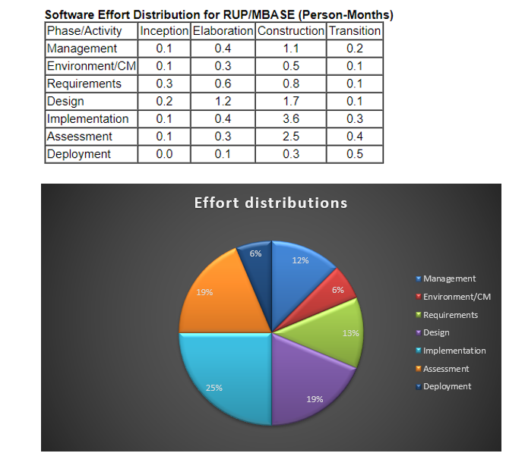

Staffing the Project

Reference: https://www.cwjobs.co.uk/browse-it-jobs

STAFF | Role Salary in year (Pound) | Number of staff | Durations in month
Project Manager | 50,000 | 1 | 7
Senior Software engineering/Team Leader | 50,000 | 1 | 5
Junior software engineering | 30,000 | 3 | 5
Requirement engineering | 45,000 | 2 | 2

Staffing Cost for the project:

- Project Manager = (role salary/12) *7 + 13% of role salary (for NI)
= 29,167 + 13% of role salary (6500)
= 29,167 + 6500 = 35,667 / for whole 7-month duration.

- Senior Software = 20,833 + 13% (6500)
= 27,333 / for whole 5-month duration

- Junior Software = (30,000/12) *5 + 13%
= 12,500 + 3900
= (16,400) * 3 (since we have 3 staff)
= 49,200 / for 5 whole month duration

- Requirement engineering = (45,000/12) *2+ 13%
= 7500 + 5,850
= 13,350 * 2 (two staff)
= 26,700 / for 2-month duration



Communication strategy table

S/No | Target audience  (stakeholder) | Frequency | Method | Owner
1 | Managing Director | Weekly | E-mails, meeting, face2face | IT dep, managers
2 | Booking Manager | Daily | E-mails, call, face2face | IT dep, booking clerk
3 | Account Manager | Daily | E-mails, call, face2face | IT dep, account clerk
4 | Activity Manager | Daily | E-mails, call, face2face | IT dep, hostel manager
5 | Issuing Clerk | Daily | E-mails, call | IT dep, account clerk
6 | Booking Clerk | Daily | E-mails, call | IT dep, hostel staff
7 | Account Clerk | Daily | E-mails, call | IT dep, booking clerk
8 | Clients/Customers | Monthly | E-mails | IT dep
9 | IT department | Weekly | E-mails, call | IT dep, clerks, hostel staff
10 | Hostel reception Staff | Daily | Call, face2face | Hostel manager, instructor
11 | Advertisement agency | Quarterly | E-mail | IT dep
12 | Consultant | Half year / yearly | E-mail | IT dep

Gantt chart

The duration of the project has been decided from cost analysis document.

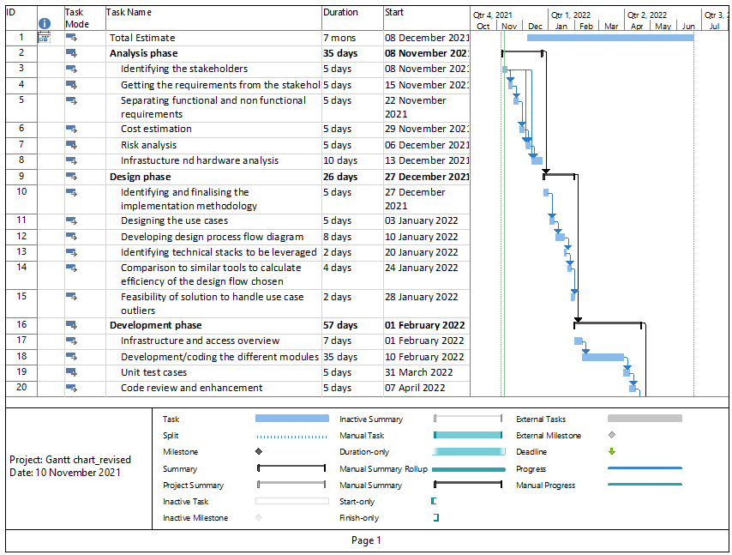



Functional and non-functional requirements

Based on the proposed system we have come up with the following functional and non-functional requirements.

Functional Requirements

- Online booking by customers.
- Online booking system that can be accessed from anywhere that can handle customer inquiries, reservation, and booking.
- The system needs to handle last-minute booking through the booking system.
- The system must allow users to search customers by booking id or name (when check-in)
- All Bookings stored at one place hence it is accessible to everyone, ensuring no overbooking
- Website accepts bookings by customers online.
- Catalogue of courses needs to be created which have details & schedules of all courses.
- Booking can be made online at hostel reception and on call where the service agent would fill the details in online form.
- Payments for account customers should be added to their account billing.
- Customers should be able to create an account.
- Customers without an account are able to make online payments using credit cards.
- Hostel reception should conduct booking using their system.
- Activity managers can change the price of the course due to promotions.
- A booking should have all details related to the customer.
- Cancellation form should be available, this should also amend the course catalogue by making the slots available which have been cancelled.
- Requests should be sent to the accounts department on cancellation of booking.
- Voucher issuing can be automated, once payment is authorized, automatic mails can go to customers with the voucher.
- The system must adapt the company hierarchy by granting different levels of access to different user account levels.
Non-Functional Requirements

- Show availability of courses, discounted courses and online payment options.
- The system needs to be a responsive interface that can adapt to any screen size.
- Send alerts to related users about the activity by push notification, system alerts or through emails.
- The system can suggest check-in customers by date or week to narrow down the search.

- Courses can be booked up to six months in advance.
- Courses can be filled by customers and also available at check-in.
- Allow multiple access without downgrading its performance.
- Available in different languages for the Customers.
- Compatibility with Different Browsers.
- Compatibility with Different Hardware.
- Uploading and Downloading speed.
- Attractive user Interface.
- Reliability and recoverability of the data present on the website.
- Protection of computer systems and networks from information disclosure, theft or damage.
- Response time of the website being between 3-5 seconds.
- Send detailed reports to managers on user activity.

System requirements

Programming languages used in the project,
- HTML/Javascript/Jquery (Front end)
- NodeJs (Server-side/ back-end)
- MySql (Database)

As the system is web-based implementation, the system can operate in a minimized configuration of hardware resources. Even though it is recommended to use

If PC/Laptop/iMac (minimum requirement):
I5 intel with 8Gb RAM
If Mobile device:
AndroidOS: Marshmallow (6.0) / RAM: 3Gb
IOS: iOS 13 / iPadOS 13

Methodology adopted

The project will be following the KANBAN methodology.

The proposed system will be a small-scale booking management system with a reporting section. As the client is looking for a fast solution to handle their business, it is important to adopt a flexible methodology to deliver the project and hence Kanban. The following are the advantages.

- The proposed system solution will be an in-house system meaning continuous updates and changes won’t be an option.
- Prevents overproduction, lowers costs, and makes operations more reflective of the demands of the market.
- Producing the exact quantity of products that are required.
- Achieve a steady flow of work, all units within the Kanban system should only produce the number of tasks based on the capacity.
- Fine-tune the Development / Process Optimization.
- Stabilize and Rationalize the Process.

